Data-response Question for the Economics Curriculum (Secondary 4-6)

The Guangdong-Hong Kong-Macao Greater Bay Area

Personal, Social and Humanities Education Section
Curriculum Development Institute
Education Bureau
2023
It is our honour to have Dr. Lee Shu Kam, Director of Business, Economic and Public Policy Research Centre, Hong Kong Shue Yan University to develop this data-response question for the Education Bureau.
Source A: A brief introduction to The Guangdong-Hong Kong-Macao Greater Bay Area (the Greater Bay Area, GBA)
The Greater Bay Area comprises a cluster of 9+2 cities in southern China (shown in the following diagram). The objectives of this plan are to further deepen cooperation amongst Guangdong, Hong Kong and Macao, fully leverage the composite advantages of the three places, facilitate in-depth integration within the region, and promote coordinated regional economic development, with a view to developing an international first-class bay area ideal for living, working and travelling.
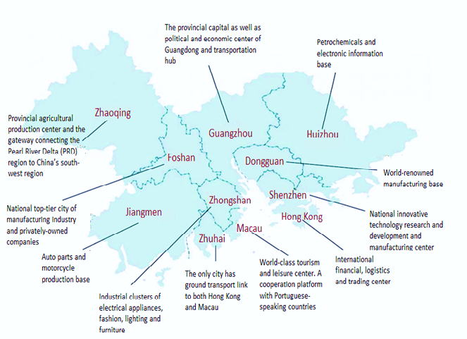
Source: Text-The Greater Bay Area Website (https://www.bayarea.gov.hk/en/outline/plan.html); Figure: Legislative Council of HKSAR. (2018). “Overview of Guangdong-Hong Kong-Macao Bay Area”.

Source B: Industrial structure of GBA cities
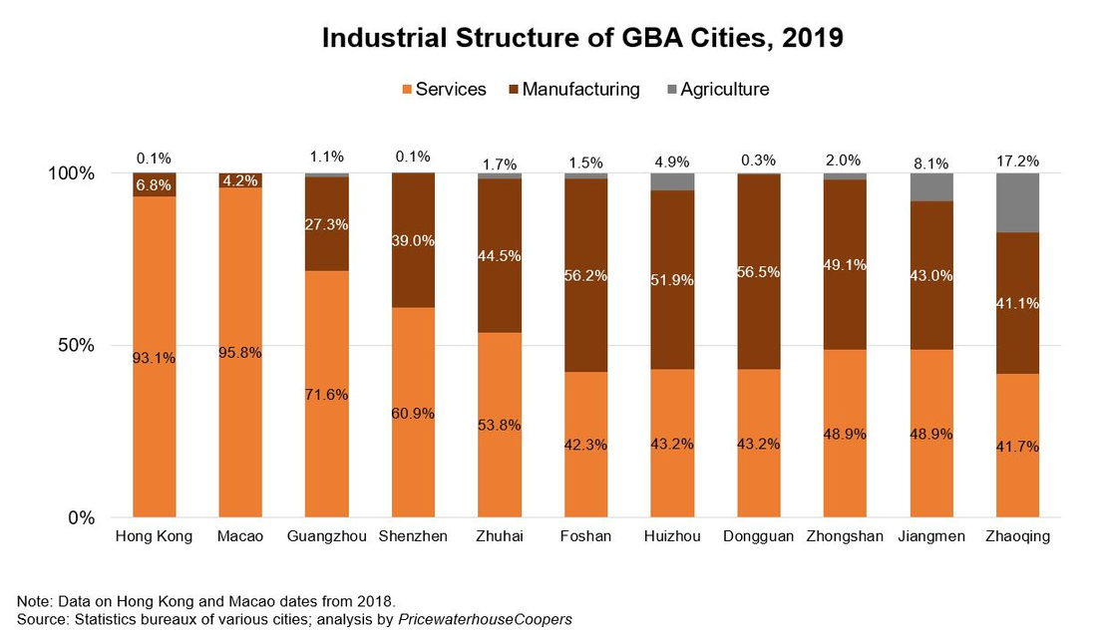
Source: Hong Kong Trade Development Council website (https://research.hktdc.com/en/article/NTM5MzY3MDA4)

Source C: Some facts about the key infrastructure connecting Hong Kong and other regions in GBA
Hong Kong Section of the Guangzhou-Shenzhen-Hong Kong Express Rail Link (XRL) | - Opened in September 2018  - Connects with the over 29 000-km National High Speed Rail Network (up to end-2018)  - Shorten substantially the travelling time between Hong Kong and other GBA cities
Hong Kong-Zhuhai-Macao Bridge (HZMB) | - Opened in October 2018  - Reduces the travelling time between the Kwai Tsing Container Terminals and Zhuhai from 3.5 hours or so to about 75 minutes  - Reduces the travelling time between the Hong Kong International Airport and Zhuhai from 4 hours or so to about 45 minutes  - Incorporates the western side of the Pearl River Delta into a reachable three-hour commuting radius of Hong Kong
Source: Greater Bay Area (https://www.bayarea.gov.hk/en/connectivity/key.html)
Source D: Some facts about the Greater bay Area Youth Employment Scheme
Greater Bay Area Youth Employment Scheme (the Scheme)
The Hong Kong Government will grant a monthly allowance of HK$10,000 to the enterprises for hiring each graduate engaged up to 18 months.
Objective: To encourage and support young people to work and pursue their career in the Mainland cities of the GBA (GBA-9)
Eligibility: Hong Kong residents holding bachelor’s degrees or above awarded by local or overseas tertiary institutions in 2021 to 2023.
Places: 1,000
Salary: Not less than $18,000/month
Station: GBA-9 to work
Others: Provision of on-the-job training

Source: Interactive Employment Service (iES) website, Labour Department, HKSAR Government https://www2.jobs.gov.hk/0/en/information/gbayes/

(a) (i) What do comparative advantage and regional division of labour refer to respectively? (4 marks)
Ans: An economy is said to have a comparative advantage in production of a good if it has lower opportunity cost in producing this good compared to another economy.
Regional division of labour refers to the workers in a region or district specialize in producing a particular good or in a particular stage of production of a good.

(ii) How are the two concepts in (i) related? (1 mark)
Ans: When making a production decision, the region would specialize in producing the good or in a particular stage of production of a good which the region has a comparative advantage in or lower production cost when comparing with other regions.

(b) Refer to Sources A and B, explain how the cooperation amongst Guangdong, Hong Kong and Macao under the GBA plan can illustrate the advantage of regional division of labour. (3 marks)

Ans: Different regions in GBA specialize in certain type of production/industry. For example, Hong Kong specializes in the financial industry, Shenzhen specializes in innovative technology industry, and Macau specializes in tourist industry. As a result, a larger volume of goods and services can be produced and hence people’s standard of living can be improved.

(c) John is a university graduate in Hong Kong and he would like to pursue his career in the Mainland cities of the GBA (GBA-9). Refer to Sources C and D, explain how his opportunity cost of working in these cities will be affected given the following situations:
- the infrastructure within these cities is improved (2 marks)
Ans: His opportunity cost of working in the Mainland cities of the GBA will reduce as the improvement in infrastructure reduces the travelling time i.e. the time cost of working there.

- the launch of the Greater Bay Area Youth Employment Scheme (the Scheme) (2 marks)
Ans: The Scheme will not affect John’s cost of working in the Mainland cities as it only increases the value (stable salary and on-the-job training) of the chosen option (working in GBA-9) without affecting his highest-valued option forgone.

(d) Refer to Source D, explain how the Scheme affect enterprises’ demand for Hong Kong graduates to work in GBA-9 (2 marks)
Ans: The Scheme provides subsidy of $10,000 as an (monetary) incentive to enterprises for them to hire more graduates from Hong Kong, that means demand for Hong Kong graduates increases.

(e) For question (e), students are required to present their answers in essay form. Criteria for marking will include the use of sources and economic theories, relevant content, logical presentation and clarity of expression.

With reference to the sources above and your knowledge in economics, discuss the effects of the plan of the Greater Bay Area on Hong Kong’s economy, including:
(12 marks)
- Labour mobility
- Aggregate output
- Employment of ONE self-selected industry sector

Ans:
First of all, the labour mobility (geographical mobility of labour) would increase due to the well-developed transportation infrastructure shown in Source C. With this infrastructure, the time of traveling within the GBA cities is greatly reduced, and the cost of traveling to work in other places within GBA will reduce. In addition, the Scheme shown in Source D provides incentive to the enterprises and Hong Kong young people to work in the Mainland cities in GBA. More young people are willing to work in GBA-9. Taking together, the geographical mobility of labour in Hong Kong will increase.

[Remark: Apart from geographical mobility, students may also argue that there is an increase in occupational mobility due to the improving infrastructure and increasing number of job opportunities in Mainland cities in GBA. While this perspective is reasonable and acceptable, teachers need to be aware that there may be policy limitations in reality and the above factors may not have significant effects on the change in occupation, particularly to those who are getting close to retirement.]

In terms of aggregate output, there can be two favourable effects caused by the plan of GBA. Firstly, the plan would increase the aggregate demand in Hong Kong. Source A shows that the plan intends to deepen the integration and cooperation of cities in GBA through regional division of labour. In this light, Hong Kong will face a greater market in GBA cities, for example, Hong Kong can provide more financial services to the innovative industry in Shenzhen. Moreover, the improved infrastructure shown in Source C attract more tourists from cities nearby to visit Hong Kong and facilitate the trading and logistics industry in Hong Kong. Therefore, Hong Kong’s re-export of goods and export of services will increase and hence the aggregate demand and output will increase as a result.

Moreover, the regional division of labour and the improved connectivity through infrastructure in GBA reduce the cost of production in Hong Kong, and the short-run aggregate supply as well as the aggregate output will increase.

In addition, when the connectivity among GBA cities improved by infrastructure and government policies under the GBA plan. Hong Kong may specialize more on financial industry and more employment in relation to financial industry would be created.

Innovation and technology industry: Uncertain as there may be more people in this industry be attracted to work in Shenzhen by the Scheme. However, there may be more people in this industry in Mainland cities coming to work in Hong Kong given the reduction of travelling time (this case is still subject to the employment policy in Hong Kong).
Tourist industry: Tourist industry may improve with better infrastructure and hence more people would be employed. ease

